Q: What do these cars have in common?

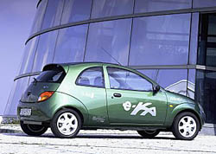 |  | 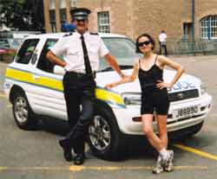
The Ford e-Ka  125 miles per charge  1p a mile | The Xebra Roadster  100 miles per charge  1p a mile | Jersey Police love their 1p a mile, 120 miles per charge Toyota Rav4-EV
A: Zero petrol-tax…oh yes and zero-emissions too…
Did you know:
- Electric vehicles cost just 1p a mile to run/charge up (equivalent to 30 - 40 pence a gallon)
- Electric vehicles can out-accelerate Porches and Ferraris
- One trailblazing family-sized electric vehicle, the Solectria Sunrise has reached 373 miles on a single £4 charge
- Ford's Ka is outpaced by its electric ‘e-Ka’ (never heard of it?)
- Electric cars are petrol tax-free and emission-free
Road tax is just £40
- So: guess why the government, oil companies, car-makers
and the media aren’t telling you all this?
- Why are the best electric vehicles ONLY available in the USA and Japan?
See www.EVUK.co.uk..
for more little-known FACTS about
electric, petrol tax-free vehicles
Q: What do these cars have in common?

The Ford e-Ka  125 miles per charge  1p a mile | The Xebra Roadster  100 miles per charge  1p a mile | Jersey Police love their 1p a mile, 120 miles per charge Toyota Rav4-EV
A: Zero petrol-tax…oh yes and zero-emissions too…
Did you know:
- Electric vehicles cost just 1p a mile to run/charge up (equivalent to 30 - 40 pence a gallon)
- Electric cars can out-accelerate Porches and Ferraris
- One trailblazing family-sized electric car, the Solectria Sunrise has reached 373 miles on a single £4 charge
- Ford's Ka is outpaced by its electric ‘e-Ka’ (never heard of it?)
- Electric cars are petrol tax-free and emission-free
Road tax is just £40
- So: guess why the government, oil companies, car-makers
and the media aren’t telling you all this?
- Why are the best electric vehicles ONLY available in the USA and Japan?
See www.EVUK.co.uk..
for more little-known FACTS about
electric, petrol tax-free vehicles

